# Portfolio Returns Calculation

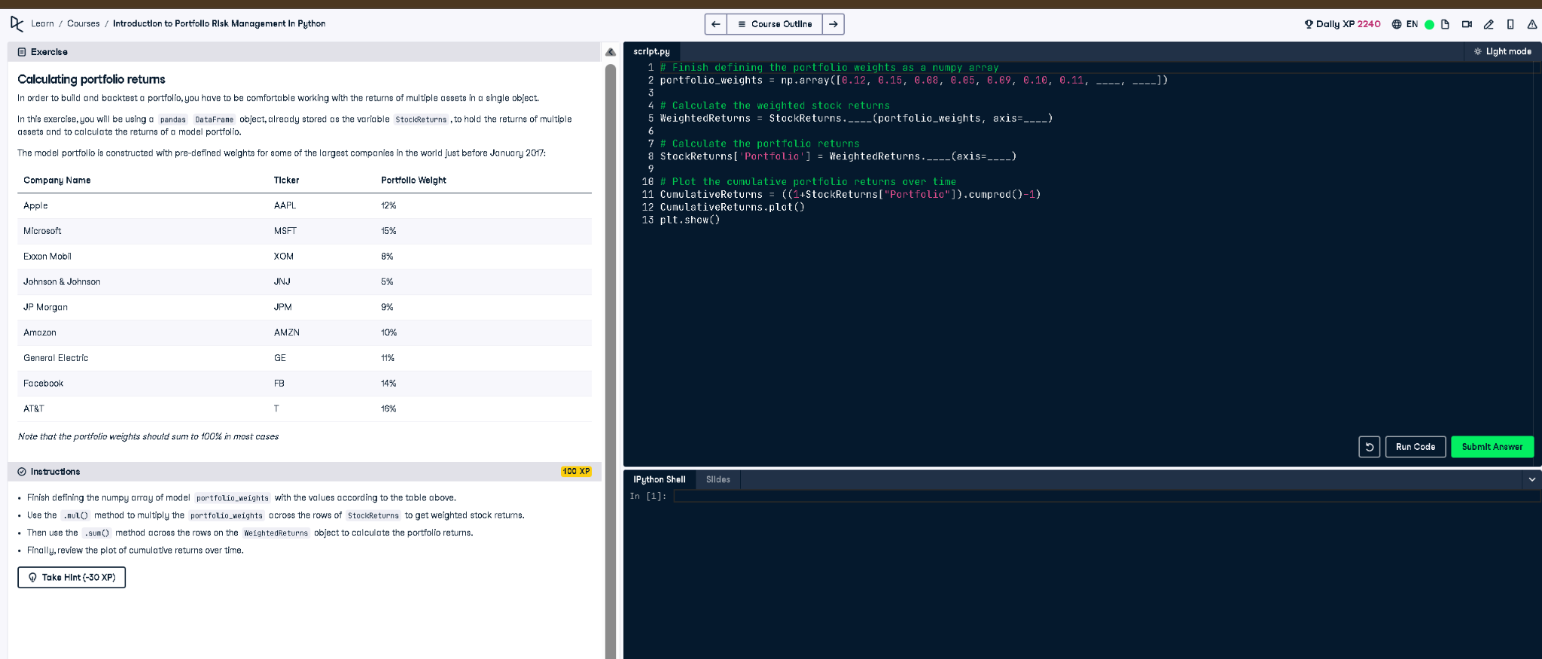

Figure: Exercise prompt and code editor

## Full Python Code

# Finish defining the portfolio weights as a numpy array  
portfolio_weights = np.array([0.12, 0.15, 0.08, 0.05, 0.09, 0.10, 0.11, 0.14, 0.16])  
  
# Calculate the weighted stock returns  
WeightedReturns = StockReturns.mul(portfolio_weights, axis=1)  
  
# Calculate the portfolio returns  
StockReturns['Portfolio'] = WeightedReturns.sum(axis=1)  
  
# Plot the cumulative portfolio returns over time  
CumulativeReturns = ((1 + StockReturns["Portfolio"]).cumprod() - 1)  
CumulativeReturns.plot()  
plt.show()

## Explanation in Simple Words

This code calculates total portfolio returns using the weighted returns of individual stocks. Each stock's return is multiplied by its weight, summed up, and stored. Then, it computes cumulative returns to show how the investment grows over time. A plot visually displays this performance over time using matplotlib.